11/24/2022
OWNER
Trinade AI PVT.LTD

FSD ON SLEEP ALARM

Table of Contents

1.Introduction
1.1. Purpose………………………………………………………………………………………………1
1.2. Scope………………………………………………………………………………………………….2
1.3. Documentation information …………………………………………………………..….2
1.4. Key words & Definitions……………………………………………………………………..2
1.5. Initiation of Project…………………………………………………………………………….3

2. Plan of Project

2.1 Project Charter……………………………………………………………………………………4
2.2 Requirements………………………………………………………………………………..……5
2.2.1 Hardware Tools……………………………………………………………………………….….5
2.2.2 Software Tools…………………………………………………………………………………….5

3. User Stories – Roles & Responsibilities
3.1. EPIC-1 Planning……………………………………………………………………….………….6
3.1.1. Developers Status Charter……………………………………………………..……………7
3.1.2. Scrum Master Status Charter…………………………………………………………….…7
3.2. EPIC-2 Action of Planning………………………………………………………………….…8
3.2.1. Action items for Developers with POC…………………………………………………8
3.3. EPIC -3 Development ………………………………………………………………………….9
3.3.1 Source code Development………………………………………………………………....9

4. Data gathering & generation

4. Model Deployment………………………………………………………………………..…10
4.1 Hardware FSD………………………………………………………………………………..…11
4.2 Software FSD……………………………………………………………………………………11

5. Conclusion
5.1 Final Report…………………………………………………………………………….………12

SLEEP ALARM
1.Introduction
These alerting devices emit an alarm or buzzing noise to alert the person they are falling asleep. It is generally used to prevent falling asleep. In case of drivers, is this anti-sleep application to keep cars, although it was designed for car drivers, it can used in other situations where you stuck, somewhere to awake.
  - Purpose
We can solve these sleepless driving and accidents, to lead healthy lives

  - Scope of the Project

The main objective to run the healthy life with smart environment to develop the sleep alarm, control the death rates.
1.3. Document Information:
Document Title | Functional Specifications Design Document
Owner | Trinade AI Technologies pvt Ltd
Status | Design Level
Quality | Cost Base
Budget | Company base
Timeline | 2022- 2023

1.4 Keywords & Definitions
- Pixel- a minute area of illumination on a display screen, one of many from which an image is composed. “The camera scans photographs and encodes the image into pixels"
- Image compression - Image compression is a process applied to a graphics file to minimize its size in bytes without degrading image quality below an acceptable threshold.
- Dot matrix - a grid of dots which are filled selectively to produce an image on a screen or paper. “a dot matrix printer"

- Phase -0

  - Initiation of Project:

- Business case -
The main goal of the project is to reduce the accidents and save lives of citizens, for saving lives we may be give the financial support to citizens, In the case of so may

organizations, pvt ltd companies, corporations, controlling traffic some Real-Time Applications it helps the type of sleep hazards people by usage of the sleep alarm, give a financial support to organizations etc.

For the sake of sleepless driving, it gives lot of benefits to those who are playing the roles without sleep at nighttime, night shifts workers on companies at power plants (mainly at Turbines).

- Feasibility study –
We can solve these sleepless driving and accidents these types of issues using sleep alarm, functionality, design and flow diagram.

- Phase -1

2.Plan of the Project:
2.1. Project charter –

- Produce marketable and good quality of sleep alarm.

- Understand and perform the fundamentals of the Hardware and Software tools and their uses.

- Be familiar with the basics of all Hardware tools.

- Observe the Safety rule while working /testing on Hardware.

2.2. Requirements
2.2.1. Hardware Tools: -
Quantity | Units | Items description | Price (INR)
1 | Pixels | Camera and its types  - ANPR cameras  - USB cameras  - Digital cameras | 20,000/-
1 | - | Raspberry PI/ Arduino Uno | 7000/- to 14,000/-
1 | - | Buzzers | 20/-  (Based on cost item quality depends)
1 | Lux/km | Light (with low illumination) | -

2.2.2. Software Tools: -

Quantity | Units | Item description | Status
1 | - | Software source code with Open CV | WIP
1 |  | Face Detection | WIP

- Phase -2
2.3. User Stories:

Initiate the Project

EPIC -3/Development
EPIC-2/ Action of planning
EPIC -1/ Planning

Task -2 Fetching source code into Hardware
Task - 1 POC with Software & Hardware

Story -1Train the Model

Story -3 Fix the bugs /Errors
Story-2 Test the Model

2.3.1 EPIC –1(Planning): -
- For Mamatha (Junior Developer): -
S.no | Task/Story | Resource assigned/Developer name | Duration (Period of days) | Task Status
1. | PPT | Mamatha | - | Np
2. | Image Compression | Mamatha | - | Np
3. | POC Video Recording | Mamatha | - | Np
4. | Face recognition | Mamatha | - | WIp

- For Ram (Scrum Master): -
S.no | Task/Story | Resource assigned/Developer name | Duration (Period of days) | Task Status
1. | Light/ luminance | Ram | - | NP

- For Ashish/Ankit (Developers): -
S.no | Task/Story | Resource assigned/Developer name | Duration (Period of days) | Task Status
1.
2.

2.3.2 EPIC-2 (Action of Planning): -
- Action Items for Mamatha:
- For Developing
- PPT Presentation
- POC of Video Recording
- Face Identification
- Camera Specifications
- Action items for Ram:
- Guidance on FSD
- Project Planning
- Feedback on Sleep Alert
- Guidance on Testing
- Action Items for Ashish/Ankit:
- Guidance on Android /iOS Authentication
- Guidance on Hardware Tools
- Guidance on Software
- Guidance on Developing

2.3.3 EPIC-3 (Development): -
- Currently working the stage of development, Capturing images
- Recording video without audio, It just record the video without any time limit, until record the video until turn off the camera.
- Research on Camera and functionality and development.

- Task -1(POC): -
- Capture the images
- Recording Video
- Face Identification and Recognition
- Testing on Software
- Fetching into Hardware
- Testing on Hardware
- Release the product

- Timelines and Stories

- Task -2(Data Fetching into Hardware): -

- Face Identification and Recognition
- Recording Video
- Software is fetching into Hardware

2.3.3.1Story -1
- Train the Model
2.3.3.2 Story -2
- Test the Model
2.3.3.1 Story-3
- Fix the Errors & bugs

3.Data gathering & generation, Validation

- The anti-sleep alarm looks for any indication that the driver’s head is tipping forward: when the earpiece senses that the has increased from zero to say 15 or 30 degrees, it sounds like beep (usual clock alarm).

- In case of student’s anti sleep alarm circuit saves both time electricity, in circuit alarm we have fix time interval like 30 minutes or 15 minutes time duration, it repeats next 30- or 15-mins time interval.

- In case of drivers, is this anti-sleep application to keep cars, although it was designed for car drivers, it can used
- It can used in other situations where you people stuck, somewhere to awake.
- We are using the sleep alert in different applications.
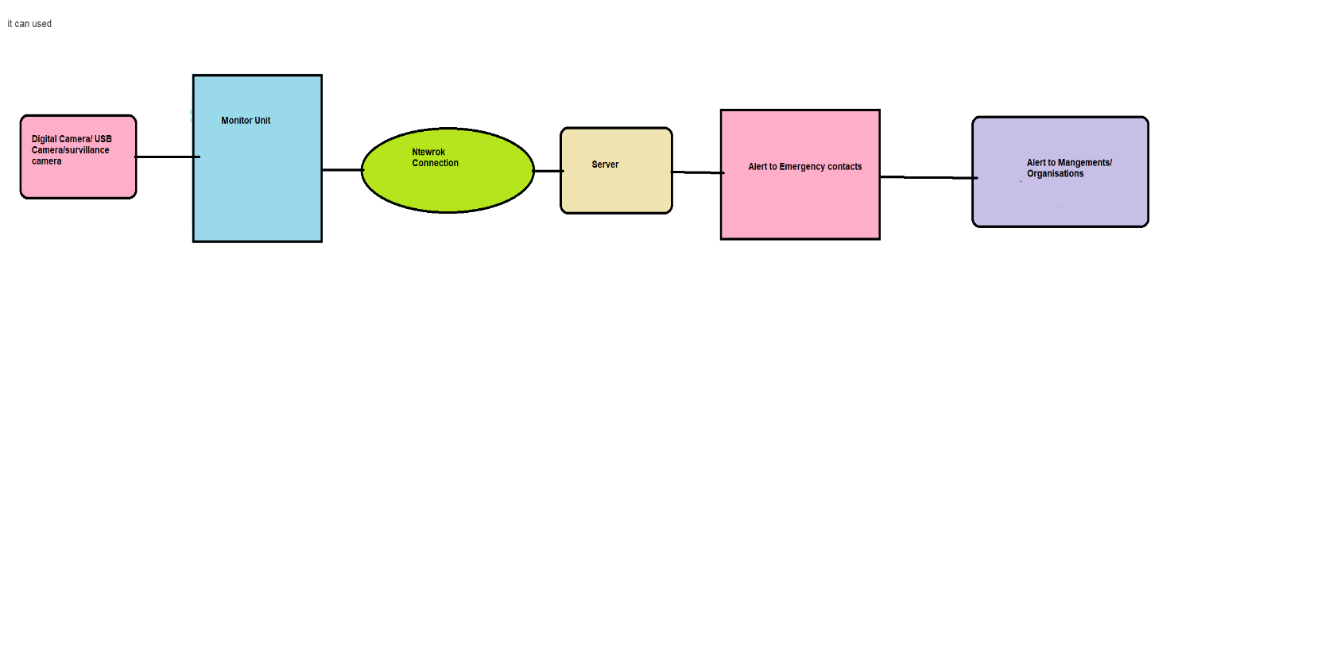
4.Model Testing & Model deployment
SOFTWARE FSD

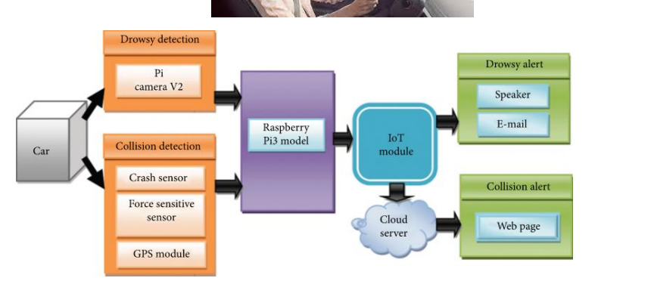
Hard ware FSD

5. Closure

5.1Final Report: -

S.no | Date | Developer | Description | Status
1. | 26/02/22 | Akshay | Overview of Sleep Alarm, POC, FSD | Np
2 | 23/03/22 | Mamatha | PPT on sleep alarm | WIP
3 | 26/02/22 | Ram | Prepare Scrum for Sleep alarm | Np

